**Microsoft Excel: Goal Seek and Solver**

**Session 6.4: Goal seek**

This document is a quick reference guide for reviewing the techniques in the laboratory.

For these exercises, download the files:

“Business Analytics – Week 6 Instructions.doc”

“Business Analytics – Week 6 Excel 2013.xls”

The goal seek command searches for a solution by varying a parameter until a solution is found.

Definitions:

Set cell: formula for the answer that you are seeking

To value: value that you want to achieve

By changing cell: the cell that changes until the Set cell matches the To value.

Let’s find the number of widgets that needs to be sold to break even for a given price. In other words, we will vary price, which will drive demand, until profit equals zero. Use the spreadsheet GoalSeek.

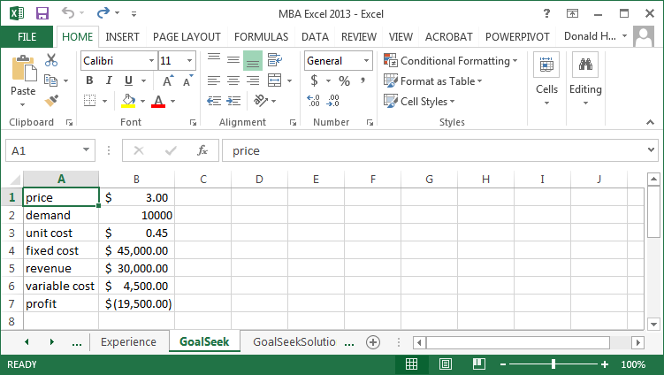

The following commands run GoalSeek.

1. Click on the Data tab at the top of the spreadsheet.
2. Click on What-if Analysis, Goal Seek.
3. For Set Cell, enter the cell that is the outcome variable that you want to match. Since we are measuring profit as the outcome, enter $B$7.
4. For the To Value, enter zero, since we are trying to find the break-even point.
5. For the By Changing Cell, enter the cell which will change, in this case price $B$1.
6. Click OK to find the solution.

You should get the solution shown below.

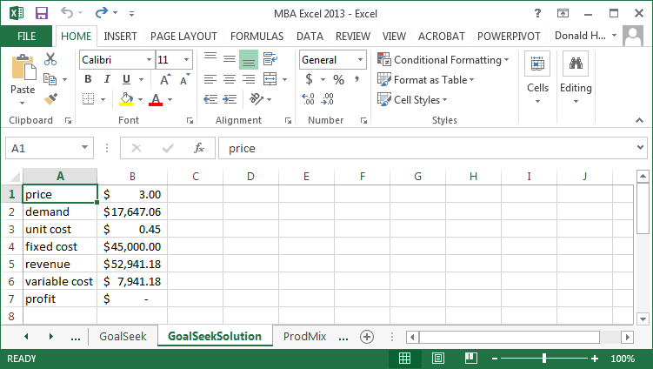

**Session 6.5: Solver Add-in**

The Solver option is available as an add-in to Excel. The steps to add it are:

1. In Excel, click on the File tab, then Options
2. Click on Add-Ins
3. Click Solver Add-in, then Go
4. Check the box for Solver Add-in, then OK

**Introduction to solver**

Solver has the ability to search for an optimal solution subject to constraint. In contrast, goal seek would search for a solution that would match a specific value, such as demand-supply=0. Solver will find the maximum or minimum of a function, called the optimal feasible solution, if one exists. In some cases, particularly overly constrained problems, there will be no solution.

**Session 6.6: Simple Optimization**

For this example, use the ProfitOptimization spreadsheet. Recall the price-demand function from earlier.

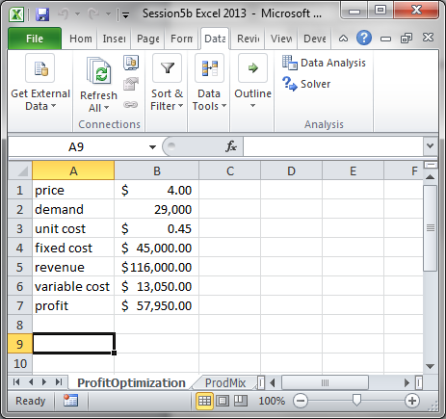

As price increases, demand decreases. Attempt to find the price that maximizes profit by changing the price.

Let’s use Solver to quickly calculate the optimal price.

1. Click on the Data tab, then click on Solver.
2. The Objective is the cell that you want to maximize or minimize. We want to maximize profit, so enter B7 in the objective, and click on Max
3. Since we want to find the price that results in maximum profit, we will change price until we find a solution. In the box labelled “By Changing Variable Cells”, enter B1, which is where price is stored.
4. Now click Solve.

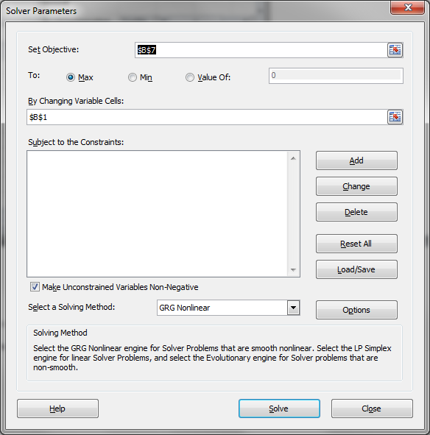

You can keep the solver solutions, or restore original values.

**Session 6.7: Useful Functions for Solver**

One function that is helpful in setting up optimization problems is the SUMPRODUCT function. SUMPRODUCT first multiplies two columns or rows together (product), then adds the resulting values (sum). In the example below, =SUMPRODUCT($D$2:$I$2,D4:I4) will multiply the values in D2:I2 against the paired value in D4:I4, i.e., D2*D4, E2*E4, etc., then add together the results. This concept will be used in each of the following chapters.

Use the ProdMix spreadsheet to see the example below.

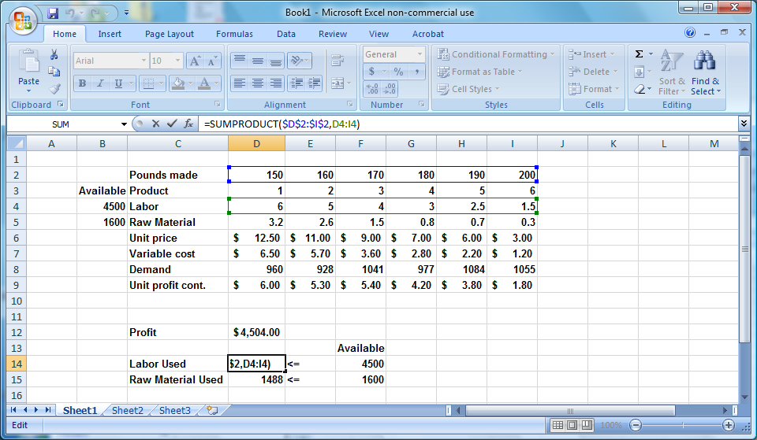

**Session 6.8: Optimal product mix**

For this problem, use the ProdMix spreadsheet.

In the optimal product mix problem, we are trying to produce six different products, where the labor and raw materials are constrained. The goal is to find the production volumes for each product that maximizes profitability.

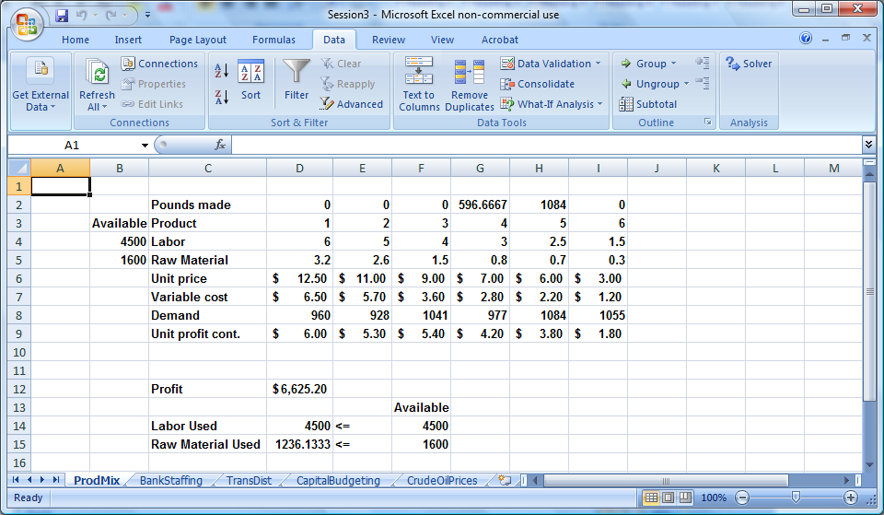

The product numbers are listed in row 3, with the labor hours and raw material required to produce one pound of that product in rows 4 and 5. The maximum demand is in row 8. The maximum labor and raw materials available are also identified. Demand, labor and raw materials are constraints.

To use solver, follow these steps:

1. Click on the Data tab
2. In the Analysis group, click Solver.
3. Set Target Cell is the cell that you want to maximize or minimize. In this case, set it to profit ($D$12)
4. Since we want to maximize profit, make sure the Max button is checked.
5. By Changing Cell refers to what you want to vary. In this case, we want to vary product quantities to find the optimal production quantities. Click in the box and set this to D2:D12. The screen should look like the picture below.

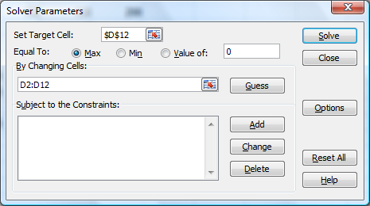

1. Next, add the constraints. First, click the Add button.
2. We want to impose a labor and resource constraint. We can do both simultaneously by entering D14:D15 and F14:F15 as below. Set the constraint direction to <=.
3. Click Add to add another constraint.

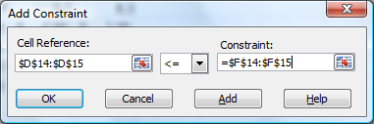

1. We also want to make sure that we don’t produce more than is demanded. After clicking add in the earlier step, Add Constraint let’s you add more constraints. In this case, production (row 2) should not exceed demand (row 8). Set this demand constraint by entering D2:I2 and D8:I8. Set the constraint direction to <=.

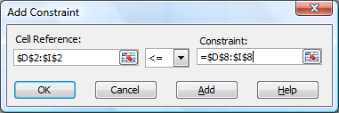

1. Since this is the last constraint, click OK. You should be returned to the following screen.

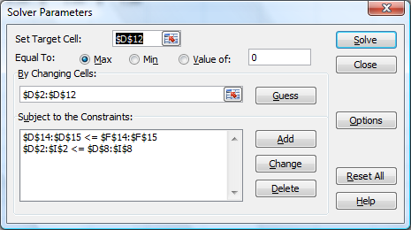

1. Next, we want to enter a constraint to make sure that the changing cells are not negative. Click the Options button, check Assume Linear Model and check Assume Non-Negative, then click OK.

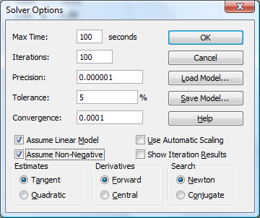

1. Linear models are guaranteed to converge to a solution. Non-linear models might not converge to the optimal solution.
2. Finally, click on Solve. Select Keep Solver Solution if you want to save your answer. You can select three reports (Answer, Sensitivity, Limits) by clicking on them.

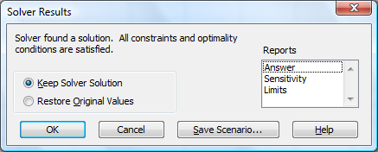

1. When you’ve made your selections, click OK. You should see the solution shown below. If you clicked on the additional reports, they will be listed as separate tabs.

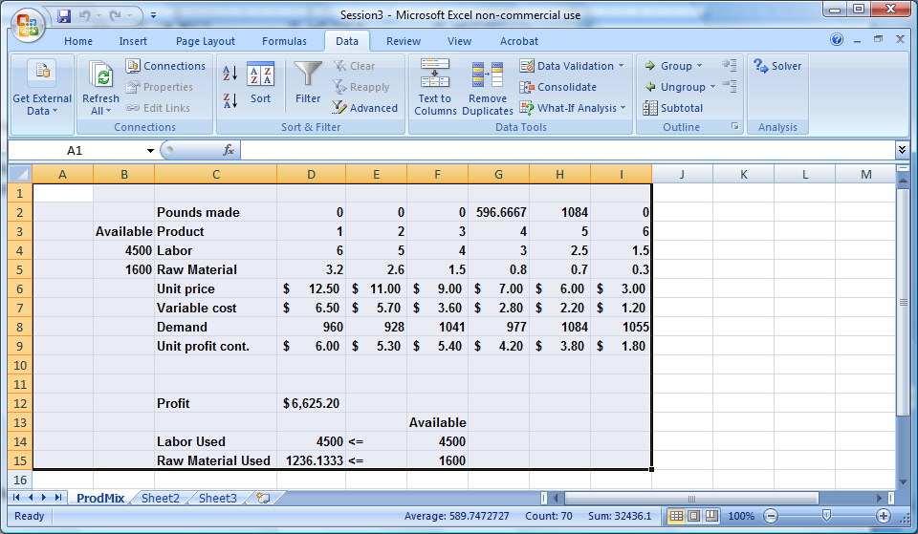

**Session 6.9: Schedule workforce**

In this example, we are trying to staff a bank with a minimum number of employees by day. The employees can work five consecutive days, starting on any one day. How many employees are needed to work in each shift? Use the Bank Staffing spreadsheet.

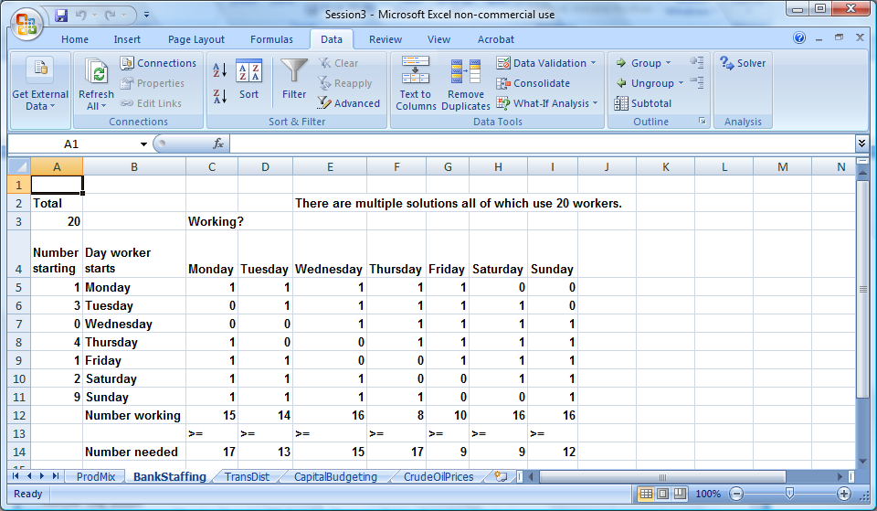

Cells A5:A11 have an initial assignment of people to shifts. Cell A5=1 means that one person will start working on a Monday. The cells C5:I5 show the days worked for a “Monday” shift. To calculate how many people are working each day, the Number working is the sumproduct. Management has determined the minimum number of employees that are required per day, listed as number needed. Now, let’s find a solution. The steps are:

1. Target cell: minimize the number of employees
2. Changing cells: number of employees who start work for each shift
3. Constraints: number of employees working must be greater than or equal to the number of employees required.
4. Also, set a constraint that you should have whole people, i.e., people are integer.

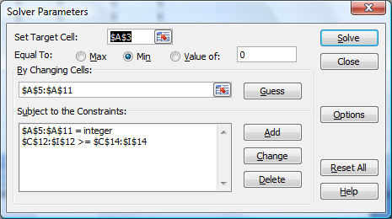

1. Finally select the options Assume Linear Model and Assume Non-Negative for the changing cells.
2. Run the solver as before.

**Session 6.10: Transportation and distribution**

The transportation and distribution problem describes an opportunity to minimize transportation costs. There are three distribution centers with inventory to be shipped to four destinations. The goal is to minimize transportation costs but satisfy demand for the products at all locations. Use the TransDist spreadsheet. The initial spreadsheet looks like the picture below:

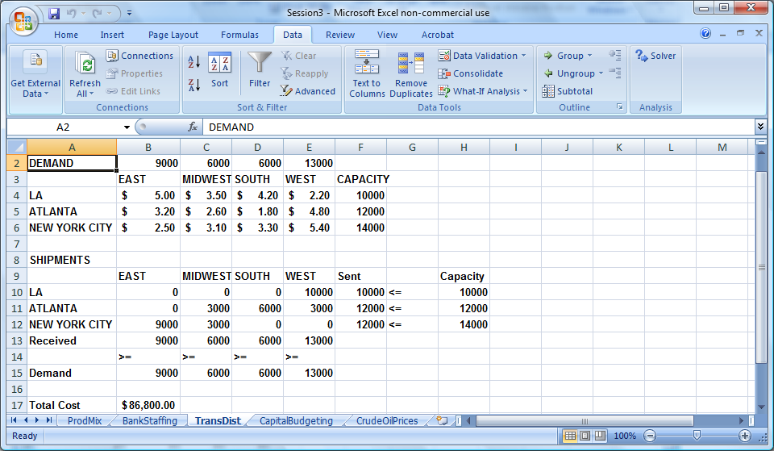

The steps to minimize cost are:

1. Set the target cell to the total cost. See the formula in the cell. Why does this work?
2. Set the changing cells to amount produced by site which is shipped to each destination.
3. Set the constraints to reflect the capacity of the distribution center. Also, the values of the changing cell should be non-negative.

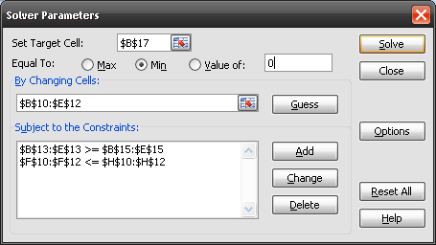

Work through this example, create the reports, and interpret the results.

**Session 6.11: Capital budgeting**

Using NPV (net present value) and IRR (internal rate of return), we are able to compare projects. Solver can be used for Capital Budgeting to select the optimal projects from a budgeting perspective.

In this case, we will use a trick called binary changing cells. A binary changing cell has a value of one or zero, reflecting that a project is selected or not. We will use a constraint of “bin” to designate a binary changing cell.

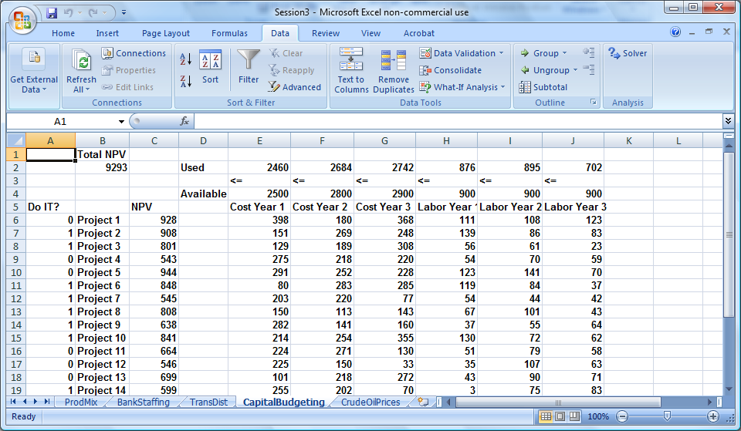

In the spreadsheet above, there are 20 projects, each with an NPV, yearly cost and yearly labor requirement. However, there also is a limit to available funds and personnel, listed in the Available row. Your objective is to select the projects within the funding and personnel constraints which maximize total NPV.

The following steps maximize NPV:

1. Set target cell to Total NPV value.
2. Set changing cells to the range of “Do it” zeroes and ones.
3. Set constraints to reflect that funds and employees used cannot exceed available.

The set up picture follows. Now run solver to see the result.

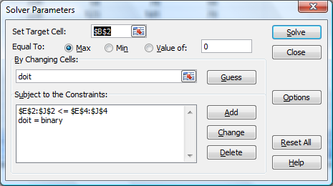

How would you handle other constraints, such as, if you select project 4, then project 3 must also be selected? If you only have four project managers, how would you limit the selection to four projects?